**Question 1**(1 point)

*Saved*

What will be the output of the following code segment:

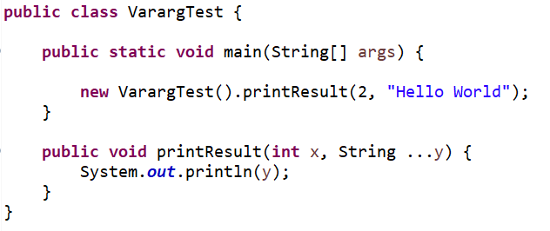

Question 1 options:

|  |  |
| --- | --- |
|  | Hello World |
|  | None of these, but printing the reference |
|  | Hello |
|  | H |

**Question 2**(1 point)

*Saved*

Varargs can be used *only* in the final argument position

Question 2 options:

|  |  |
| --- | --- |
|  | True |
|  | False |

**Question 3**(1 point)

*Saved*

What will the following code print:

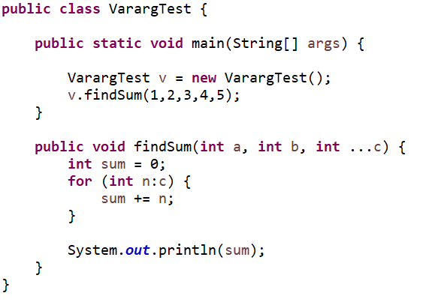

Question 3 options:

|  |  |
| --- | --- |
|  | 15 |
|  | 5 |
|  | 12 |
|  | 9 |

**Question 4**(1 point)

*Saved*

What is the output of the following code:

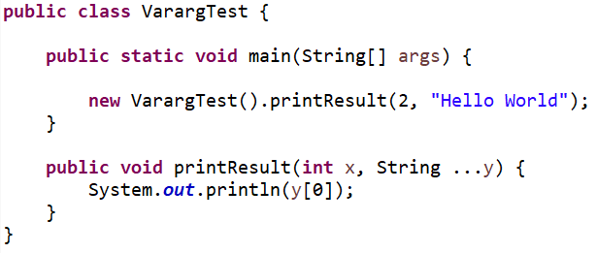

Question 4 options:

|  |  |
| --- | --- |
|  | none of these, but printing reference |
|  | Hello World |
|  | H |
|  | Hello |

**Question 5**(1 point)

*Saved*

What will be the output of the following code segment:

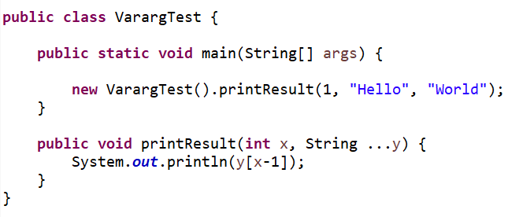

Question 5 options:

|  |  |
| --- | --- |
|  | Hello |
|  | H |
|  | Hello World |
|  | None of these, but printing the reference |

**Question 6**(1 point)

*Saved*

What will be the output of the following code:

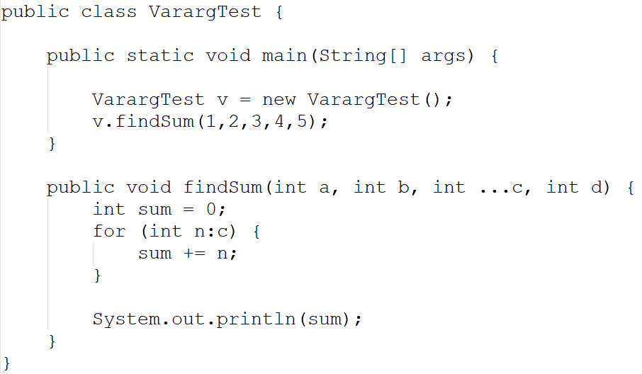

Question 6 options:

|  |  |
| --- | --- |
|  | 12 |
|  | 15 |
|  | 7 |
|  | None of these |